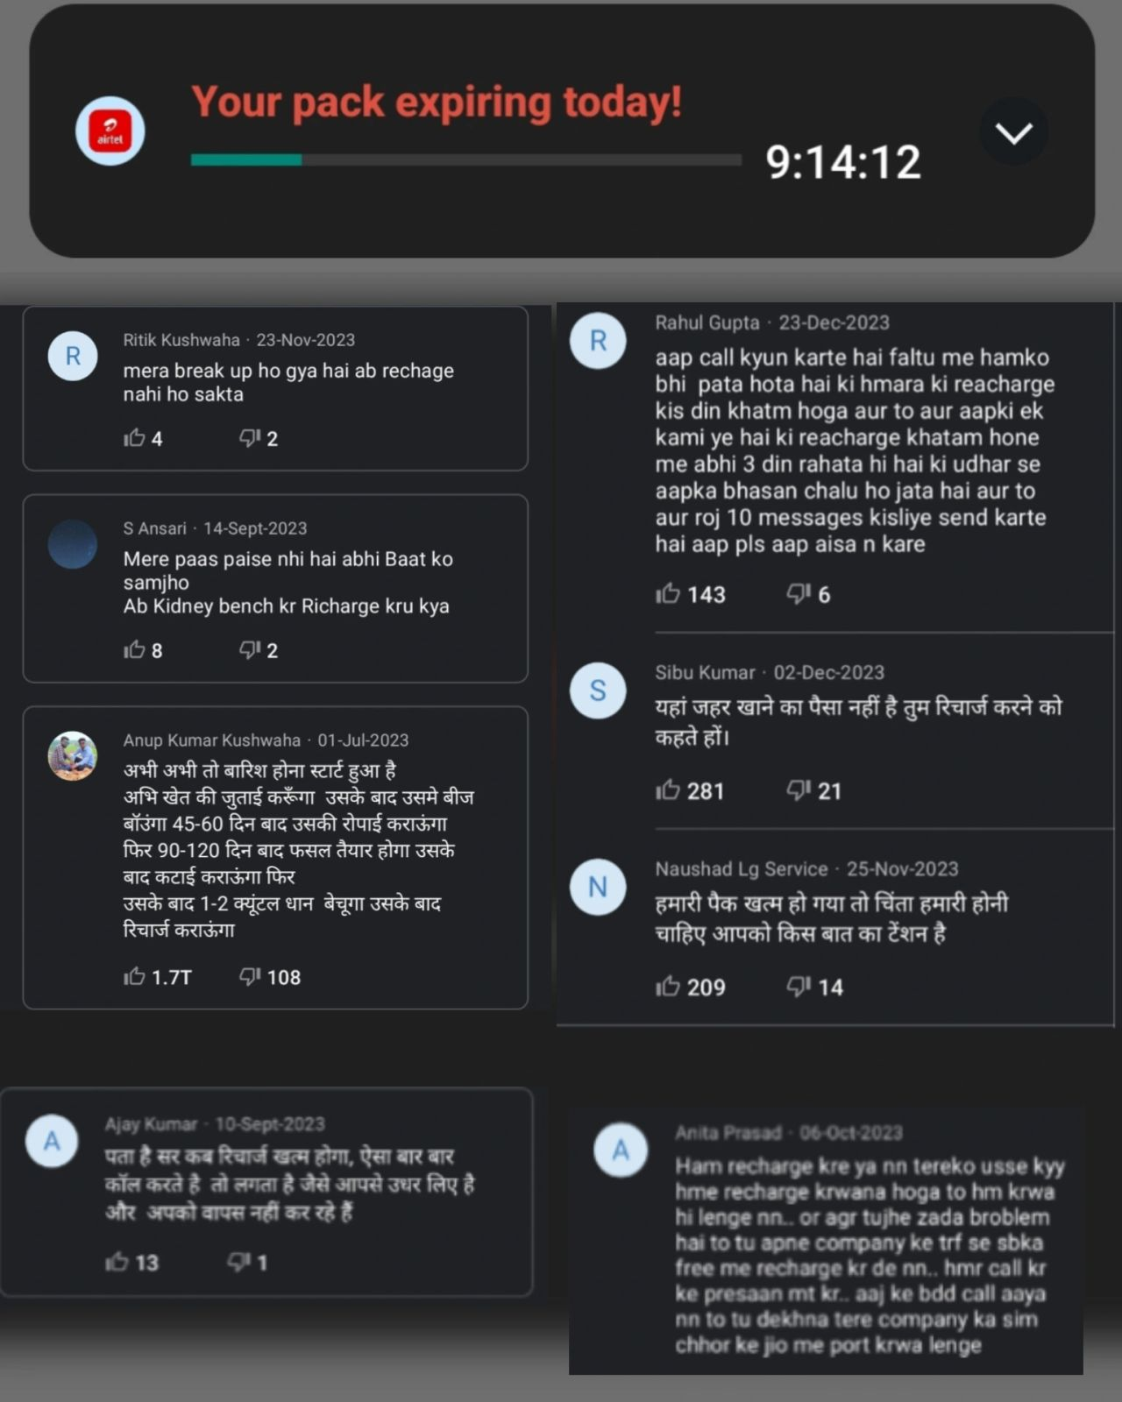
I forgot to recharge my phone, my life is ruined.

Said no Indian ever. 😶‍🌫

Unless you're an upper SEC A person who prefers living an ultra private life with no faith in the collective,

or you're super important and avoid using regular phones because the CIA is after you,

Not having recharge in the phone was seldom a problem.

You're surrounded by phones, and Indians love to borrow, share and sustain.

What airtel is doing does make sense from a BeSci pov-

1. A time bar/countdown to create a Sense Of Urgency on my airtel app.

2. Constant Reminders via automated calls telling us to recharge.

Again, doubling down on the urgency, and triggering recall.

Benifits?

If it were to be user centric, I can think of airtel trying to take care of its users via helping them avoid the inconvenience caused when they run out of a recharge.

Like? I have no clue, you tell me. (unless it is an emergency).

I'm the guy who asks the shopkeeper for a hotspot when making UPI payments if I'm out of data.

Really, what are you solving for?

I went through Truecaller reviews of the spam calls and had a ball of a time 😂

1. One person says they feel like this is an extortion call by recovery agents.

2. Other says they need to start working on the year's harvest to get the money for recharge.

3. Another says they just had a breakup and recharge isn't needed anymore.

4. Few even said they'd port to Jio if this goes on.

Just another day of looking at "nudges" backfiring because one did not apply it in the right context.

When we say "user centric" design, it must also benifit people and not annoy them solving for things that do not need solving.

Warna gali bhi pad sakti hai.

